LINUX 01
- UBUNTU – It is a linus based operating system.
- Gitbash – windows based operating system.
- Linux – it is secured operating system.
It’s a multi user operating system. Where at a time multi user can use the operating system.
Its open source operating system. Means its free to operate and login.
It is CLI( command line interface).
Falovours of linux :unbutu
RHEL (REDHAT ENTERPRISES LINUX)
AMAZON LINUX
SUSE
CENTOS
Except the packages similar commands are used in the above falvours.
- Windows – it is a single user operating system.
Its based on GUI ( graphical user interface).
- Shell – it is porgramme which takes the input and gives output.
Types of shells : bash(bourne again shell)
Sh ( bourne shell)
- Terminal – it is tool where we excute the shell commands. Also called as CLI.
---- In windows we call folder where in linux we call folder as directory---
- echo $0 – it is used to find the shell which we are operating. Currently we are using the latest one bash shell
- root directory (/) : root directory indicates with farword lash ( /).
It is the head of the all directoroies.
Under Root directory all the directories will be found.
- Home directory ( ~) : home directory indicate with tild symbol (~).
Home directrory created based upon the user when users more then home directory be more.
- pwd – present working directory
it is used to find the directory which your working present.
- cd – change directory
it uses like mouse in windows , where cd command works like to move one directory to another directory.
- cd .. – is used to go one step back side.
- cd ../.. – is used to go 2 step back word .

- cd ~ : it is also used for diretly go home directory.
- cd / : it directly goes to root location.
- ls (list) : which shows list of the directories.
- ll (long list ) or ll -ltr or ls -l: which shows list of the directories with details like date time , size of the file ,owner of the file and user of file complete details of the file we can get to known
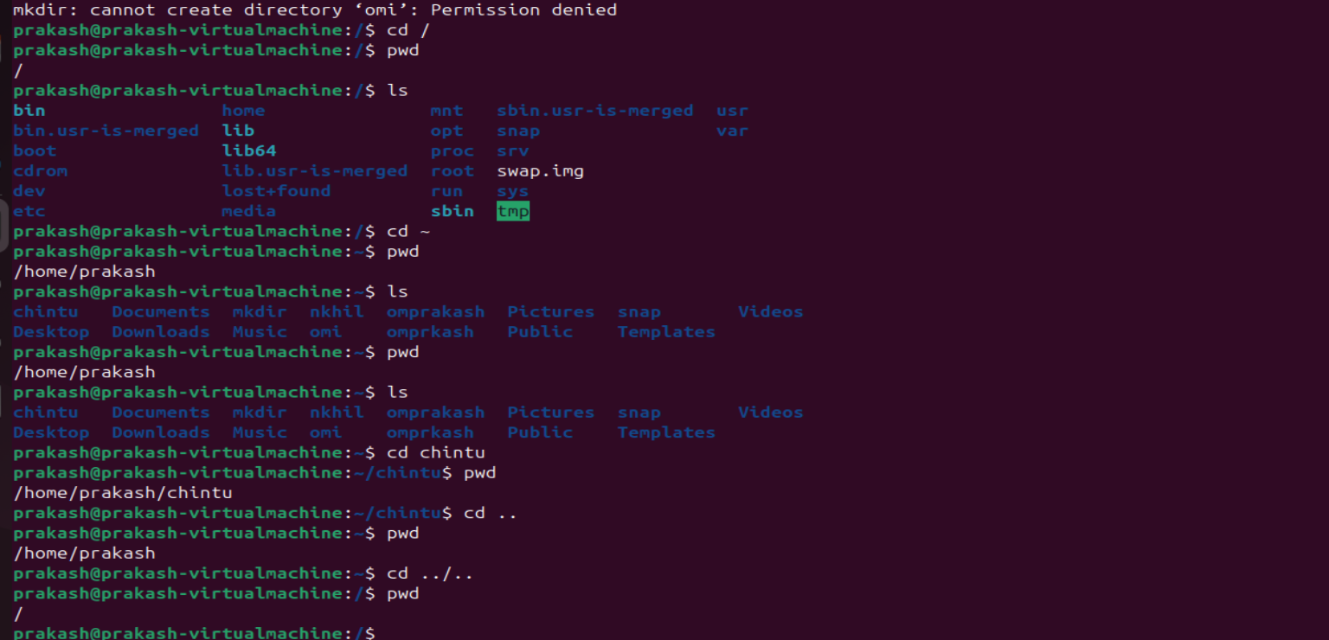

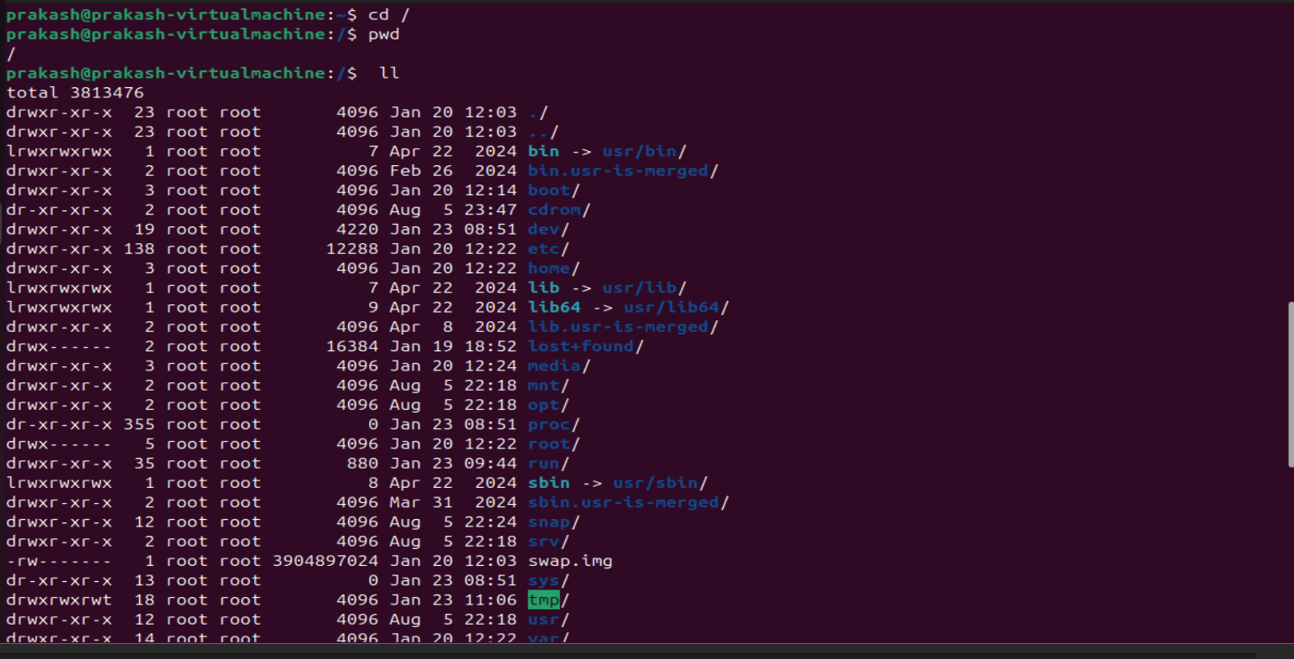
- ls -a : to get hidden file ls -a command entered.
- mkdir : is used to create the directory where windows this directory called as folder.
- mv (move) : it is the command also used to move the file from one place to another.
- mv filename .filename ( ex; mv prakash .prakash ) : it is command used to hide the file.
- mv .filename filename ( ex; mv .prakash prakash ) : it is the command used to remove from hidden gallery.
- 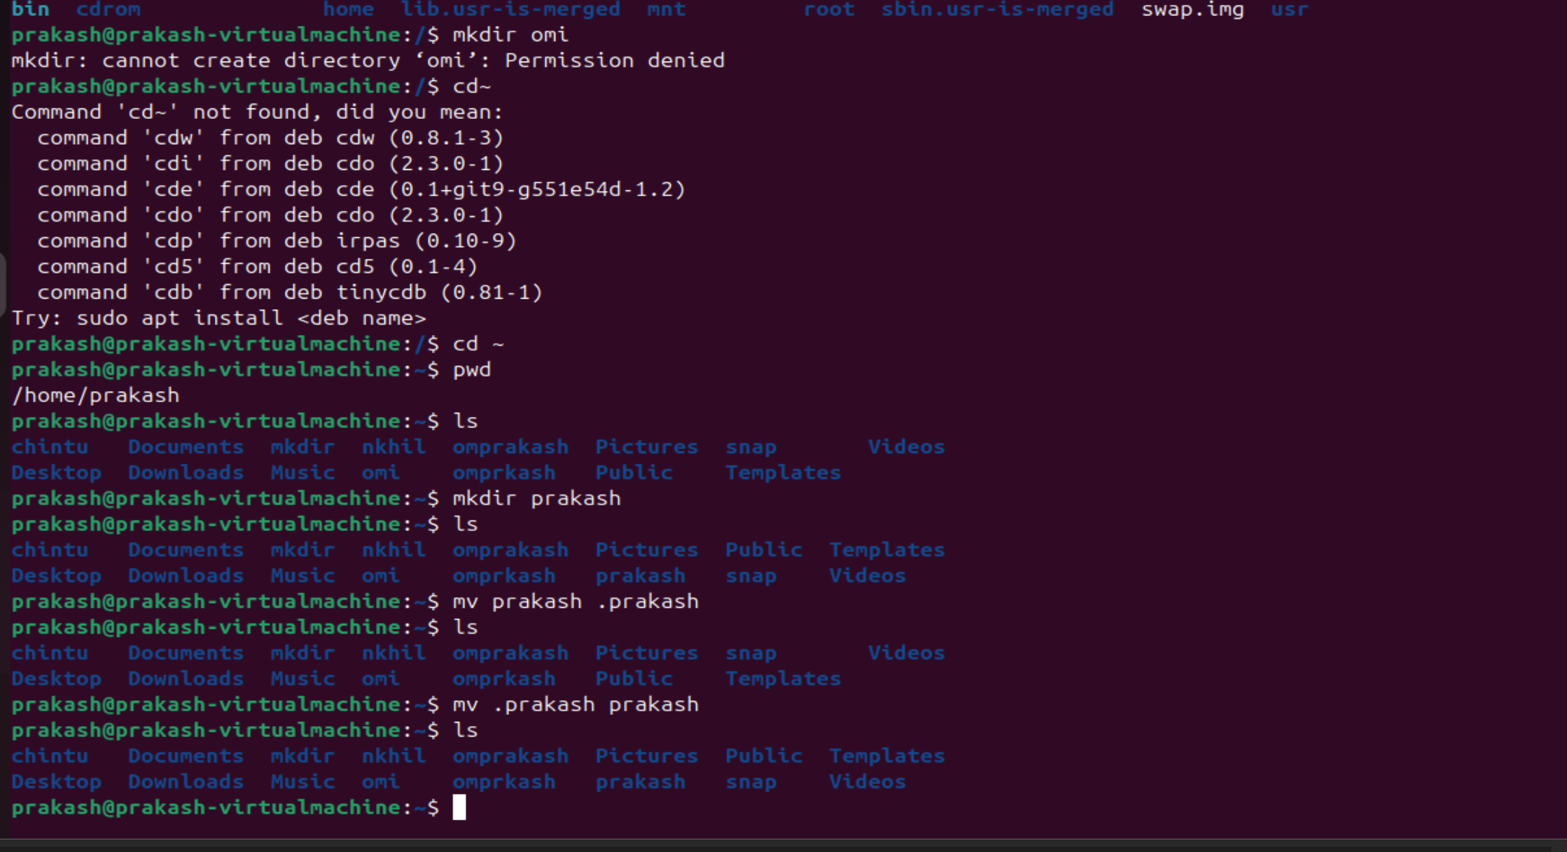

- rm -rf filename (ex: rm -rf prakash) : it is the command is used to delete the file.
- cp- it is command is used to copy the file.
- mv – it is the command is used to cut and paste the file.
- Touch – it is the command is used to create a file with th size of zero. To add the any text or data in the file, we should enter the command called VI where we can create some text by press I word we can create some text in that file.
- There are 3 types of editors in the linux : VI , VIM ,NANO.
- ESC:wq! -it is used to save text in the file.

